Jennifer Chung ([jrc98@njit.edu](mailto:jrc98@njit.edu))

### Homework #5 - Web Forms with Flask, Docker, PyCharm, and MySQL

1. GitHub Repository -

2. Submit a word document with screen shots of the following:

1. The project showing that you can view YOUR data tables in pycharm

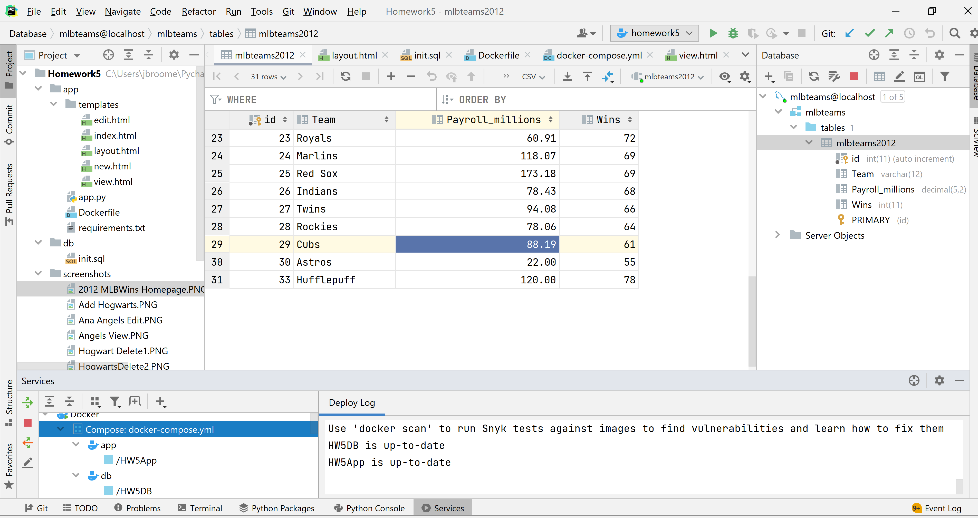

1. YOUR project running correctly in the browser displaying your homepage with your data

**Home Page** - <http://localhost:5000/> MLB Team Wins for 2012

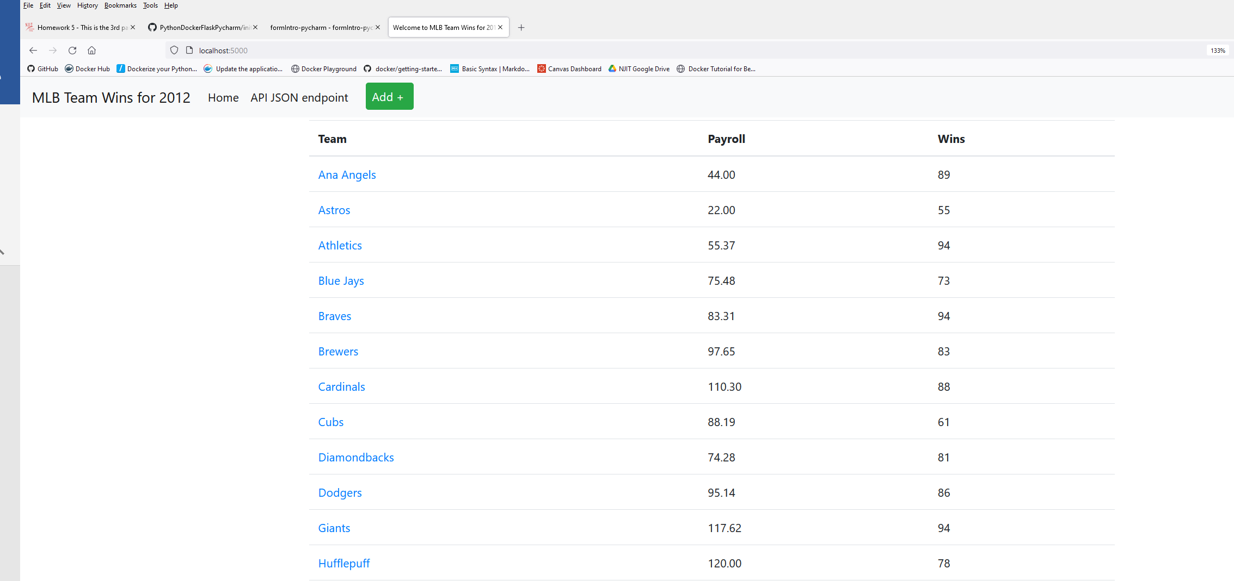

1. YOUR project running correctly in the browser displaying your data record as a view of one record

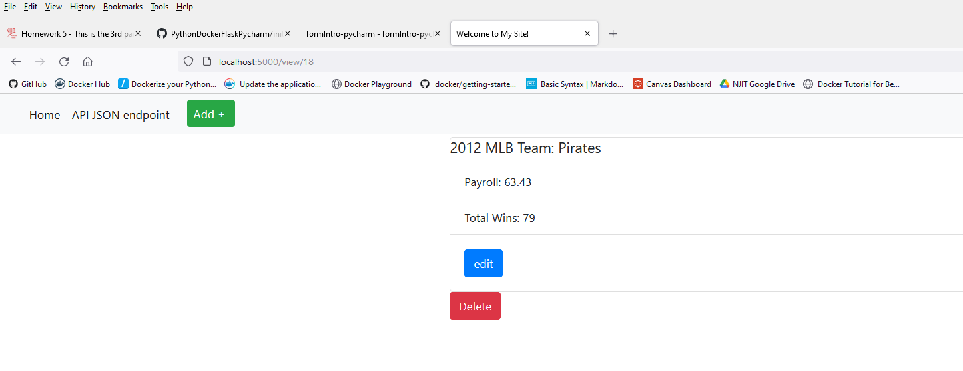

1. YOUR project running correctly in the browser displaying an updated record added to your home page

Data Before Update:



Data After the Update:

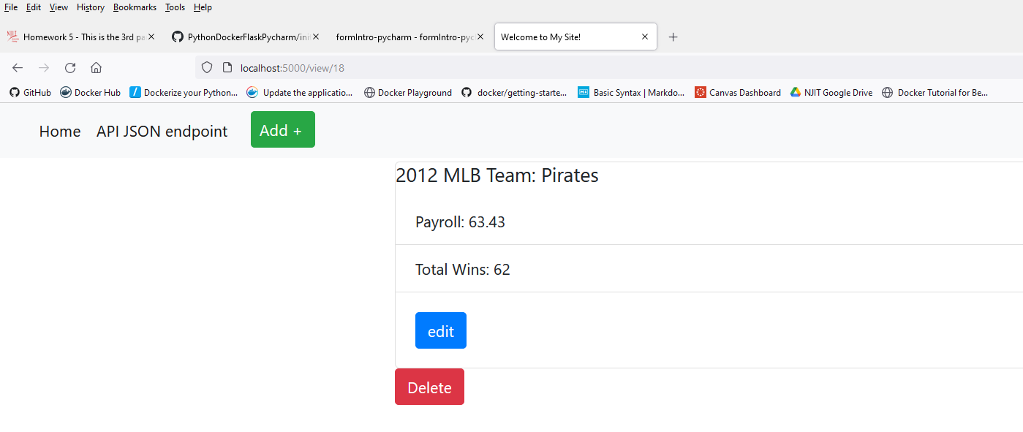

1. YOUR project running correctly in the browser displaying a new record added to your home page

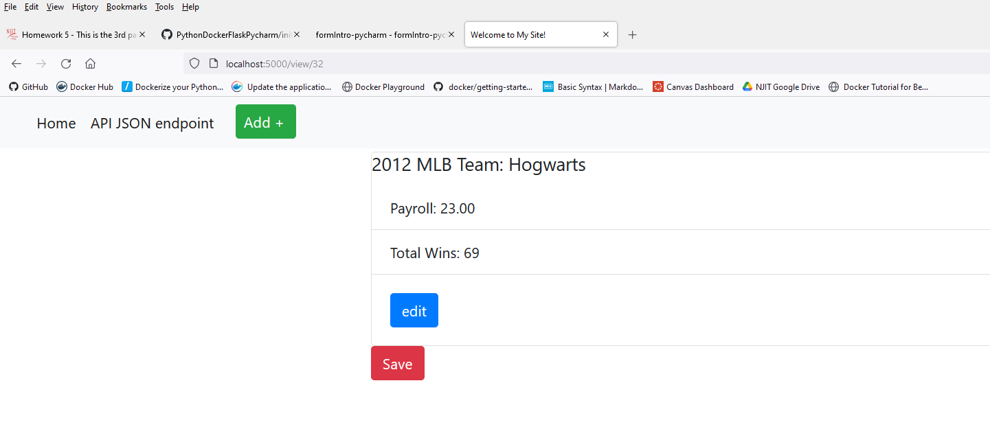

1. YOUR project running correctly in the browser displaying a deleted record added to your home   
   page

